INTRODUCTION

Agriculture, as a holistic field continues to one of the major contributors to GDP (Gross Domestic Product) of many developing countries. (Banson, Nguyen and Bosch, 2016). It has long been recognized, in particular, by developing economies as the critical sector that could help achieve the much needed global goal of poverty reduction, in a much more sustainable way (Ghana Ministry of Food and Agriculture, 2015).

In Ghana, the agricultural sector continues to be the largest contributor to the economy in terms of its GDP. It contributes to about 38% of the GDP and employs 41.9% of the Ghanaian population. It also accounts for about 75% of the export earnings (Enu and Atta-Obeng, 2013), and contributes to meeting more than 90% of the food needs of the country. (EPA, 2012).

In sub-Saharan Africa, employment rate in agriculture accounts for half of employment between 1999 and 2009. The increase in percentage of the agricultural sector is as a result of none development of non-agricultural activities to absorb the fast growing population (America and Data, 2000).

With most countries in Africa classified as developing countries, Africa houses the lowest household internet penetration, and in the developing world. The usage of internet access in the developing world recorded 24% as of 2012 in most households.

The situation in Ghana is no different, thus, a developing country with a populace of 25,546,000. 4.27% of people with access to the internet per 100 inhabitants was recorded as of 2008. In 2010, it recorded 7.8% of its populace with access to internet and by end of the year ending 2012, there was 17.11% higher than 15.27% average of the Sub-Sahara Africa (ITU, 2013b).

Several challenges faced within the agricultural sector include and not limited to land infertility, problem with finding market, and irregular rainfalls. The improper usage of chemical fertilizers and feeds leads to too much agricultural run-offs, creating bad and toxic water sources (underground water, ponds, lagoons, seas) etc., attenuation of plant nutrition and emission of nitrous oxides(<https://tradingeconomics.com>). Climatic changes occur as a result of monsoons and global warming effects all inhabitants the world over. Climatic changes are one of the major determining factors of rainfall, and hence affects cropping patterns worldwide.

As such, a vast vicissitudes of technologies ranging from low to high end cutting technologies including irrigation platforms, sensor-node systems, vertical farming, aeroponics and the likes are implemented in this sector to improve upon and enhance the yield and productivity in this field.

RELATED WORKS

A blend of MCUs (Atmega-328P) and raspberry-Pi together with an abstract number of soil moisture sensors, placed at various points on the field to monitor soil water content, and these information is relayed to base node for comparison with default settings, in order to trigger a pump or solenoid valve to operate through sending messages via internet correspondence was proposed by (Kumar Sahu and Behera, 2015).

Also, the use of an android app together with an Arduino Yun MCU which provides exchange of information to switch solenoid valves according to its requirements coming from a control unit. A server is used to act as a mediator between the control and regulation part, thereby enabling communication in an internet network, without the need to make use of a public IP address approach was implemented by (Koprda and Magdin, 2015).

The usage of IoT (Internet of Things) to have control over irrigation and monitoring of a farm site was also proposed by (Rukhmode *et al.*, 2017). The system implementation connects physical sensing devices with the cloud and connects the irrigation control mechanism with the cloud, to keep an immense analysis and problem-solving capability to the overall architecture.

(Effah, Dorgloh and Effah, 2016), proposed a gsm based irrigation system fitted with a metering mechanism to prevent overwatering or under-watering at farm site using GSM technology.

Observing from the various implementations to assist in irrigation technology in agriculture, most of these systems are efficient though, but not with its limitations. With gsm, being the cost of sending messages and availability of a mobile operator available at that location, with android app and arduino Yun MCU, Raspberry-Pi and atmega-328p approach also, the farm operator does not have a visual feedback of the status of the farms environmental conditions. And with only, the IoT implementation, the system provides a visual feedback though, the operator does not interact with the system, but its automated.

This project aims to unify all the weakness of these systems and provide a much better irrigation platform for farms sites. It seeks to provide self-automation, provision of visual feedback, and operator control mechanism using an android phone and analysis of farms environmental conditions over a period using IoT, Wemos D1 MCU, an android app and a website specifically tailored for farm operator.

SENSING FARM OPERATIONS

On a farm site, there are various environmental conditions which helps the growth of farming crops and plants. These conditions including and not limited to humidity, temperature, dew-point and soil water content. With the help of sensors, these conditions obtained in digitized form from the analog values.

Humidity: It’s important to make photosynthesis possible. The higher the humidity, the less evaporation of water occurs, and hence keeps the stomata open, but when there is too much evaporation of water occurs, the stomata closes and hence photosynthesis stops.

A DHT11/22 sensor is used for measuring humidity and temperature. It consists of a humidity component, a NTC (negative temperature coefficient), which means that resistance decreases with increasing temperature. For measuring humidity, the conductivity of two electrodes containing moisture between them changes hence affecting its resistance, thus, these changes are measured and processed by IC (integrated component) which makes it to be read by the connected MCU.

Soil water content: The soil moisture sensor, is used to measure the volumetric content of water inside the soil and gives moisture level as output. When there is more water, the soil will conduct electricity which means there will be less resistance. Using LM393 comparator chip to stabilize voltage to 3.3v-5v and metallic probes, analog values read by the sensor is mapped in percentage values to be easily read in digitized form.

ACTUATORS controls;

SENSORS (DHT11/22 and soil moisture sensor) reads:

FARM

Water pumps

Solenoid valves

Dew-point

Humidity

Temperature

Soil Water content

UPLOAD OF ENVIRONMENTAL CONDITIONS TO CLOUD

The Wemos D1 MCU (microcontroller unit) interfaced with a bunch of sensors, actuators including water pumps, solenoid valves, DHT11 and soil moisture sensors to read humidity, temperature, dew-point and soil water content are placed on the farm site. And these data obtained after about a six-hour period interval, are uploaded to the cloud using Thingspeak cloud services, serving as the intermediary control side or a server. The Thingspeak cloud service graphs data collected by sensors on the farm site using embedded MATLAB algorithms to provide visual feedback to the operator over time



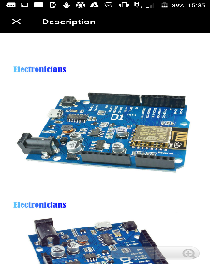 

SYSTEM MONITORING AND RESPONSE

An android app, fetches data, from the cloud service to provide a numerical equivalent to operator, who then can control the solenoid valves or water pumps to irrigate the farm land. Notifications on the soil water content level are also indicated to the farmer to prompt an alert. If there’s no reply from farm operator after a prefixed set time of about 15 minutes, the irrigation system automatically irrigates itself. The system can also be set to irrigate itself automatically, by comparing environmental conditions with default variables set within the MCU.

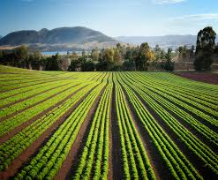 

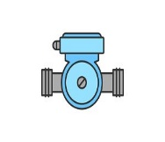 

SYSTEM DESIGN

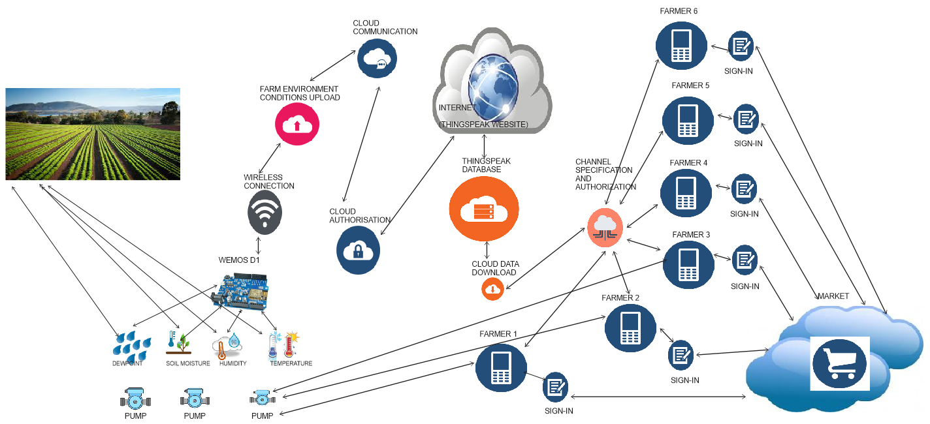

The figure above, shows the conceptual and abstract model of how the system works.

SCHEMATICS OF THE SYSTEM

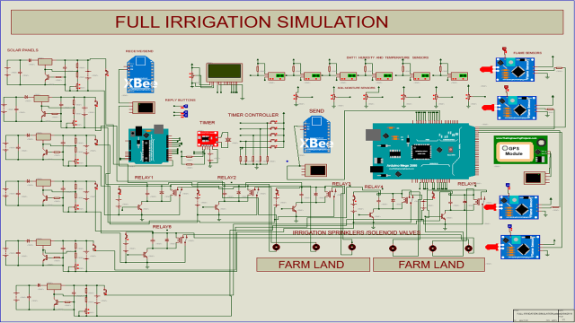

* The electronic schematic using Proteus for the abstract model of the system is shown above.
* Various humidity and temperature sensors (DHT 11/22), flame sensors, GPS sensors, and soil moisture sensors are interfaced with an Arduino Mega, together with an XBEE shield to forward sensor node data from farm site to the web server.
* These sensors data are transferred via an XBEE shield to the receiving end (an Arduino Uno) acting as a website server to receive the incoming sensor data.
* The timer module keeps track of the pre-set settings, such that, if the soil water content is low and a farmer does not reply within the required time frame, the microcontroller activates the actuator to trigger the pumps to irrigate the farm autonomously.

Simulation Run and Output Analysis Using Eltima Serial Port Driver

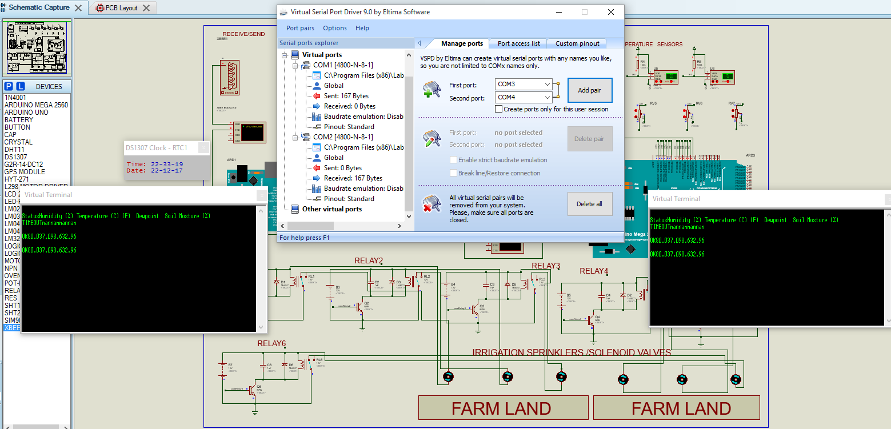

Fig: Exchange of Data between nodes from one microcontroller to another

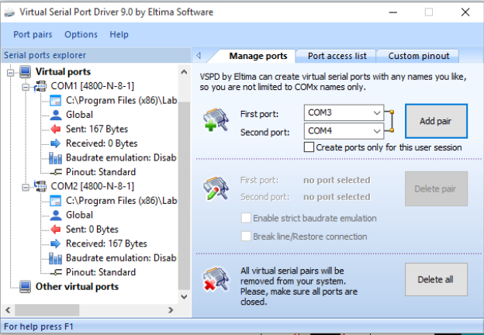

Fig: Flow of Data Sent Between the two XBEE Shields Hosting the Sensor Nodes to Base Node

3D Model of the System Using Fritzing

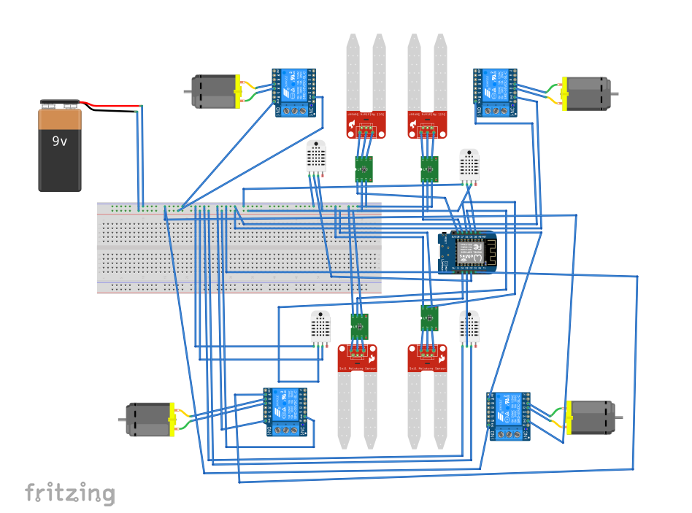

The above is a diagram depicting a graphical representation of the how the physical prototype would look like in the real world.

* The soil moisture sensors are connected to LM393 comparators to stabilize the voltage, then connected to the MCU together with other sensors (DHT22).
* The motor (actuator) are interfaced with a relay, which switch from low power voltage of the MCU to drive high power water pumps to irrigate the farm.
* A 9V battery is fed to the breadboard the power the various circuit components.
* The system then operates based on their settings and pre-set mode.

Graph Analysis on Thingspeak cloud service

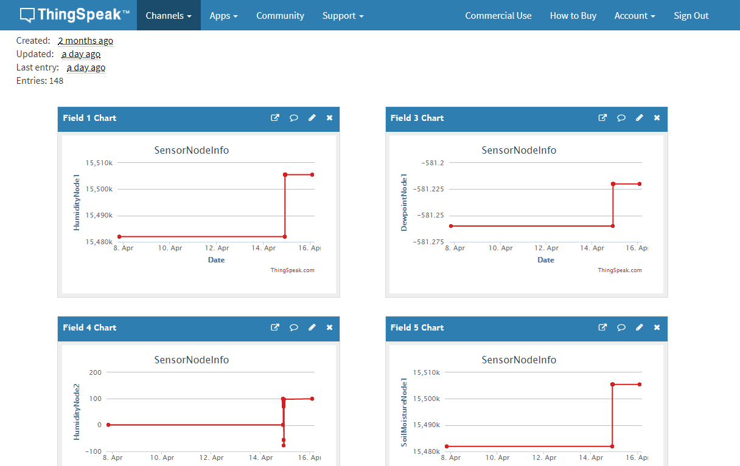

Fig:A Graphed Output of Environmental conditions in Thingspeak Channels

Pump Channel

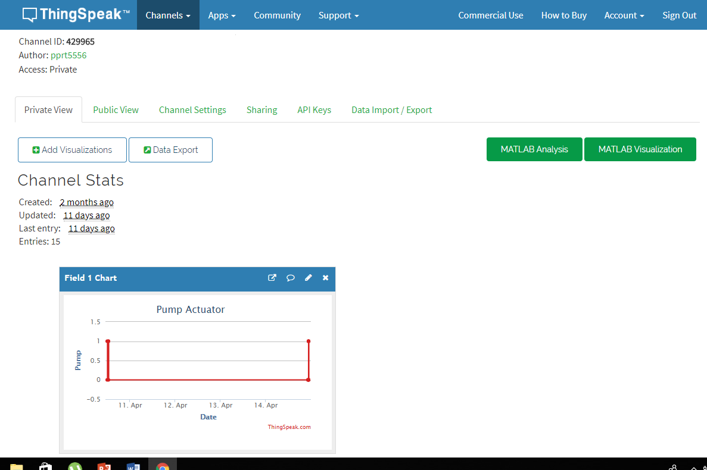

A Graphed Output Showing the State of the Pump in Thingspeak Website

Upon analysis, of the environmental variable channels, the pump state can be turn on to irrigate the farm. A (1) means the pump state is ON, and thus, the farm is being irrigated, and a (0) means the pump state is OFF, meaning the soil moisture content is OK, and the farm site is in a balanced soil water condition.

Farmers Website and Visual Graph Output

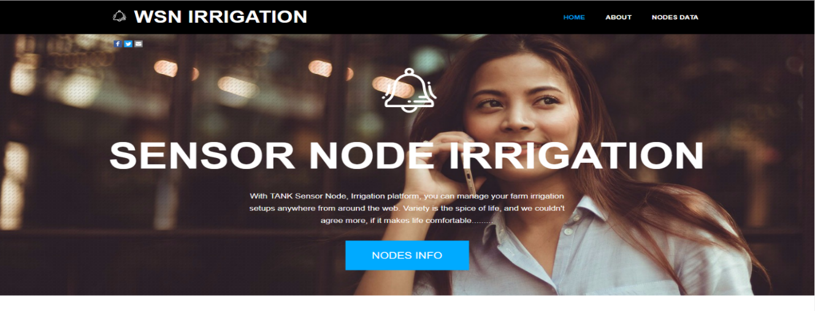

A Snapshot of Personalized Farmers Website

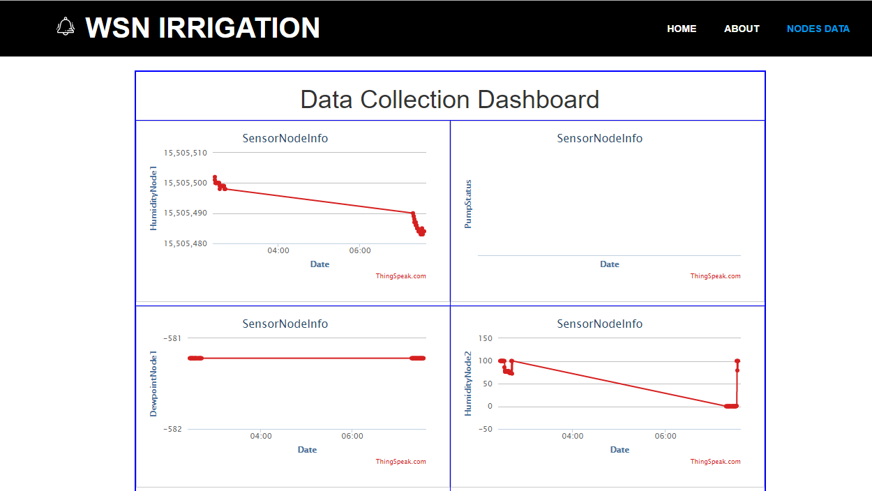

A Snapshot of Data Collection Dashboard Showing Farm Environmental Conditions on the Website

The above diagram is a personalized website keeping track of what goes on the farm, from graphing to visualizing and making decisions. With this website, a farmer can log on to his website, with the channel data being obtained from the Thingspeak server, to see what’s ongoing on his/her farm.

Android App

|  |  |
| --- | --- |
| C:\Users\STHIGWGFWB\Desktop\Screenshot_20180426-094328.png | C:\Users\STHIGWGFWB\Desktop\Screenshot_20180426-094312.png |

With the advent of android apps, being easier to use and handy for most individuals, an android app is specifically developed to obtain data from a specified channel of each farmer to view graphed data in numbered value form. Also, with this android app, a farmer can irrigate his/her farm with the push of a button, if an alarming message prompt is received showing (Soil Humidity is too low) by pressing either PUMP ON/ OFF.

Physical Prototype Implementation

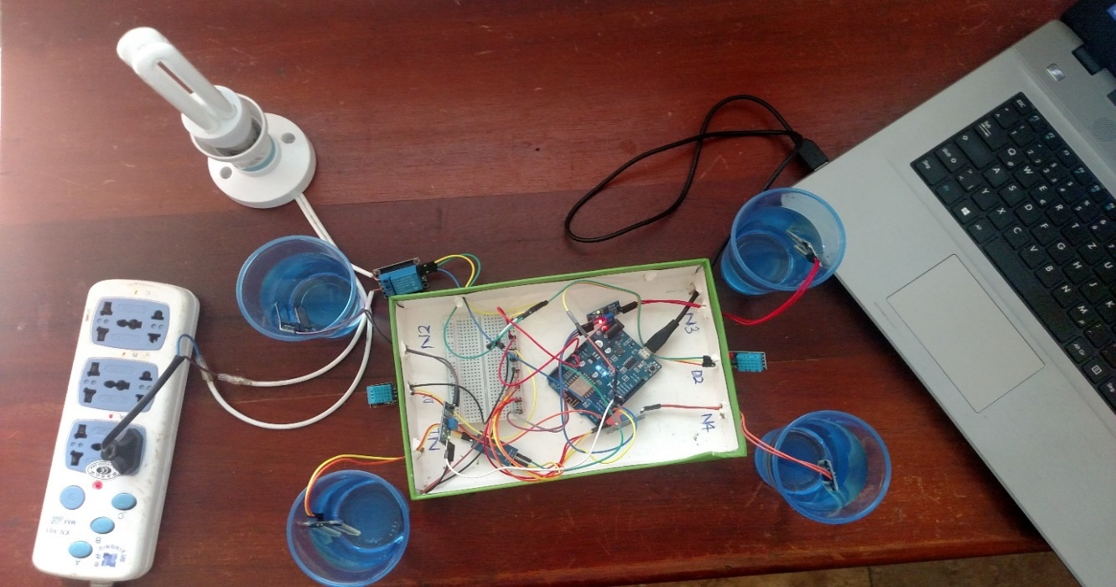Test Results of the Proposed System When All Farm Conditions Are Met.

The above is a diagram depicting the prototype. It works based on the logic already defined in the above. If the soil moisture content is high (OK), the lamp goes off. As can be seen, the four (4) soil moisture sensors are each placed in water cups, showing each node has available water content, depicting that on a farm, the soil moisture content is enough for the crops grown on the farm.

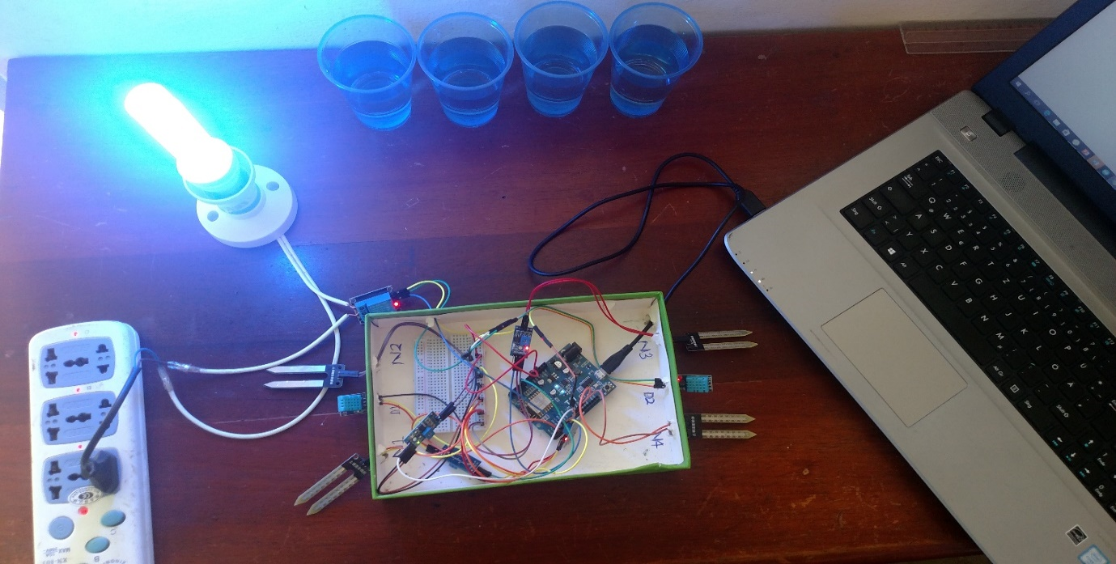

##### Test Results of the Proposed System When All Conditions Are Not Met.

As can be seen now, the lamp is ON, indicating the soil moisture content is not enough or too low. The sensor data obtained by soil moisture sensors are interpreted by the microcontroller unit, which in turn controls the relay, to turn the lamp ON, indicating, the pumping operation of the water pump, thus, the farm land is being irrigated.

Cost Analysis

### Table 4.1 Cost Analysis

|  |  |  |  |
| --- | --- | --- | --- |
| Component | Quantity | Unit Price | Price(Gh₵) |
| Wemos D1 | 1 | 14.99 | 14.99 |
| DHT 11 humidity and temperature sensors | 2 | 4.45 | 8.9 |
| YL-69 Soil moisture sensors | 4 | 2.41 | 9.64 |
| Relay | 1 | 11.31 | 11.31 |
| Self-priming 12V liquid pump | 1 | 30.21 | 30.21 |
| Light bulb | 1 | 6 | 6 |
| Light bulb holder | 1 | 3 | 3 |
| TOTAL | | | 84.05 |

Dollar rate: $1.00 = Gh₵ 4.45 (February, 2018).

CONCLUSION AND RECOMMENDATION

The focus on the objective of this project was to simulate and design a prototype of an irrigation system which could be controlled by an operator using IoT, autonomously irrigate itself and obtain a visual feedback of various environmental changes occurring on a farm site. Therefore, it can be concluded from the achieved set objectives that, farming will play a vital role in the upcoming years of this 21st century, and hence, there is a need for smart farming to improve efficiency, water management, crop monitoring, soil management, control of insecticides, and pesticides. Also it helps minimizes human efforts, simplifies techniques of farm irrigation and along with these features, it can help to grow the market for farmers with single touch and minimum effort.

REFERENCES

Banson, K. E., Nguyen, N. C. and Bosch, O. J. H. (2016) ‘Systemic Management to Address the Challenges Facing the Performance of Agriculture in Africa: Case Study in Ghana’, *Systems Research and Behavioral Science*, 33(4), pp. 544–574. doi: 10.1002/sres.2372.

Effah, E., Dorgloh, W. and Effah, E. (2016) ‘GSM-Controlled Irrigation System ( GSMCIS ) for Vegetable Farmers in Ghana \*’, (1), pp. 1–4.

Ghana Ministry of Food and Agriculture (2015) ‘Facts and Figures’, (2015). Available at: http://www.agrofood-westafrica.com/fileadmin/user\_upload/messen/agrofood-Westafrica/Brochure/AGRICULTURE-IN-GHANA-Facts-and-Figures-2015.pdf%0Ahttp://cairngorms.co.uk/discover-explore/facts-figures/.

Koprda, Š. and Magdin, M. (2015) ‘New Trends and Developments in Automation in Agriculture’, 4(Ii), pp. 1492–1494.

Kumar Sahu, C. and Behera, P. (2015) ‘A low cost smart irrigation control system’, *2nd International Conference on Electronics and Communication Systems, ICECS 2015*, (Icecs), pp. 1146–1151. doi: 10.1109/ECS.2015.7124763.

Rukhmode, S. *et al.* (2017) ‘IOT Based Agriculture Monitoring System Using Wemos’, (March), pp. 14–19.

Business, G., Buildings, G. and Road, W. (2000) ‘Internet Use ( Agridata 2000 )’, (June), pp. 485–490.

Enu, P., Hagan, E. and Attah-obeng, P. (2013) ‘IMPACT OF MACROECONOMIC FACTORS ON INDUSTRIAL PRODUCTION IN GHANA’, 9(28), pp. 238–254.

Gertz, E. and Justo, P. Di (2012) *Environmental Monitoring with Arduino*, *O’Reilly Media*. doi: 978-1-449-31056-1.

Gómez Maureira, M. A., Oldenhof, D. and Teernstra, L. (2014) ‘ThingSpeak – an API and Web Service for the Internet of Things’, *World Wide Web*. Available at: http://mediatechnology.leiden.edu/images/uploads/docs/wt2014\_thingspeak.pdf%0Ahttps://staas.home.xs4all.nl/t/swtr/documents/wt2014\_thingspeak.pdf.

Hedley, C. *et al.* (2009) ‘Wireless Soil Moisture Sensor Networks for Precision Irrigation Scheduling’, *Landcare Research, Massey University*, pp. 1–10.

Banson, K. E. *et al.* (2015) ‘A Systems Thinking Approach to Address the Complexity of Agribusiness for Sustainable Development in Africa: A Case Study in Ghana’, *Systems Research and Behavioral Science*, 32(6), pp. 672–688. doi: 10.1002/sres.2270.

Business, G., Buildings, G. and Road, W. (2000) ‘Internet Use ( Agridata 2000 )’, (June), pp. 485–490.

Enu, P., Hagan, E. and Attah-obeng, P. (2013) ‘IMPACT OF MACROECONOMIC FACTORS ON INDUSTRIAL PRODUCTION IN GHANA’, 9(28), pp. 238–254.

Masuki, K. F. G. *et al.* (2010) ‘Role of mobile phones in improving communication and information delivery for agricultural development: Lessons from South Western Uganda’, *ICT and Development - Research Voices from Africa. International Federation for Information Processing (IFIP), Technical Commission 9 – Relationship Between Computers and Society.*, (March), pp. 1–13. Available at: http://mak.ac.ug/documents/IFIP/RoleofMobilePhonesAgriculture.pdf.

Muriithi Gikandi Anthony, B. E. & O. A. S. (2009) ‘Information Technology for Agriculture and Rural Development in Africa: Experiences from Kenya’, *Conference on International Research on Food Security, Natural Resource Management and Rural Development*.